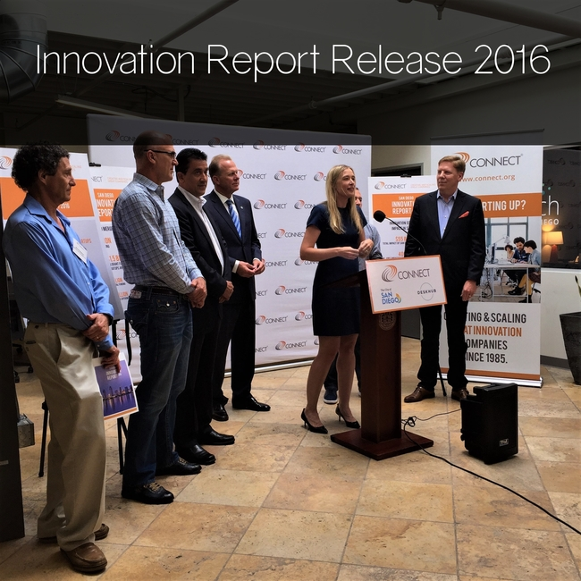
It was great to celebrate San Diego entrepreneurs and the innovation economy at today's (2017-08-03) press conference releasing the 2016 San Diego Innovation Report!
Thank you to Mayor Kevin Faulconer for championing the San Diego innovation economy and helping us launch this year's report.
Thank you also to our entrepreneur representatives - Jerry Feitelson of Agribody Technologies, Peter van Rooyen of Edico Genome, Jennifer Worralll of Iteros, and Mike Kamdar of Molecular Assemblies.
Click here to view the 2016 Innovation Report

